David Mariani

650.483.4491

INSTRUCTIONS FOR exporting CONSTITUENTS data from FINALSITE for pds church office

Table of Contents

Exporting Data from Finalsite 3

Step 1: Login to Finalsite 3

Step 2: choose Constituents Manager from the drop down 4

Step 3: choose settings from constituents manager screen 5

Step 4: click on export data 6

Step 5: On the export drop down, select parishioners 7

step 6: enter the updated since box and click on the compile export button 8

step 7: click on the export to excel button 9

Correct Data for Import into PDS Church Office 10

Step 1: Remove all fs_ prefixes from the finalsite field 10

step 2: Change “primary contact” to “head of household” for CUSTOM3 FIELD 11

step 3: Change active/inactive to true/false in CUSTOM4 field 12

step 4: Split the file into families.csv and members.csv 13

# Exporting Data from Finalsite

First launch your **Windows VM** by clicking on the **Virtual Box** icon and then bring up your web browser and enter the following address: <http://angels.finalsite.com/admin.cfm>

## Step 1: Login to Finalsite

Login to Finalsite and choose **Constituents Manager** from the drop down

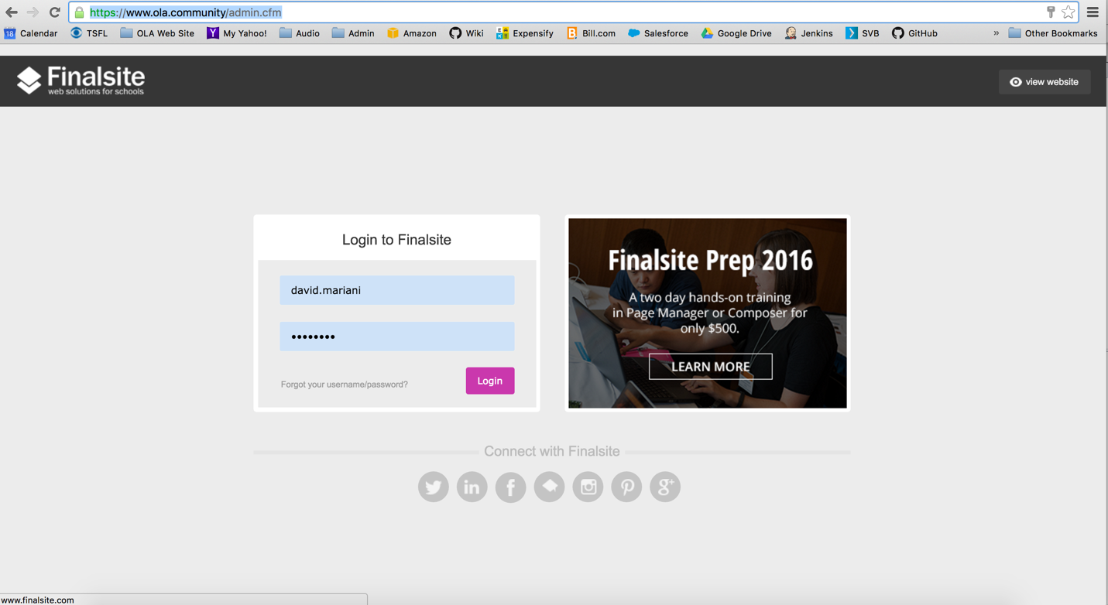

## Step 2: choose **Constituents Manager** from the drop down

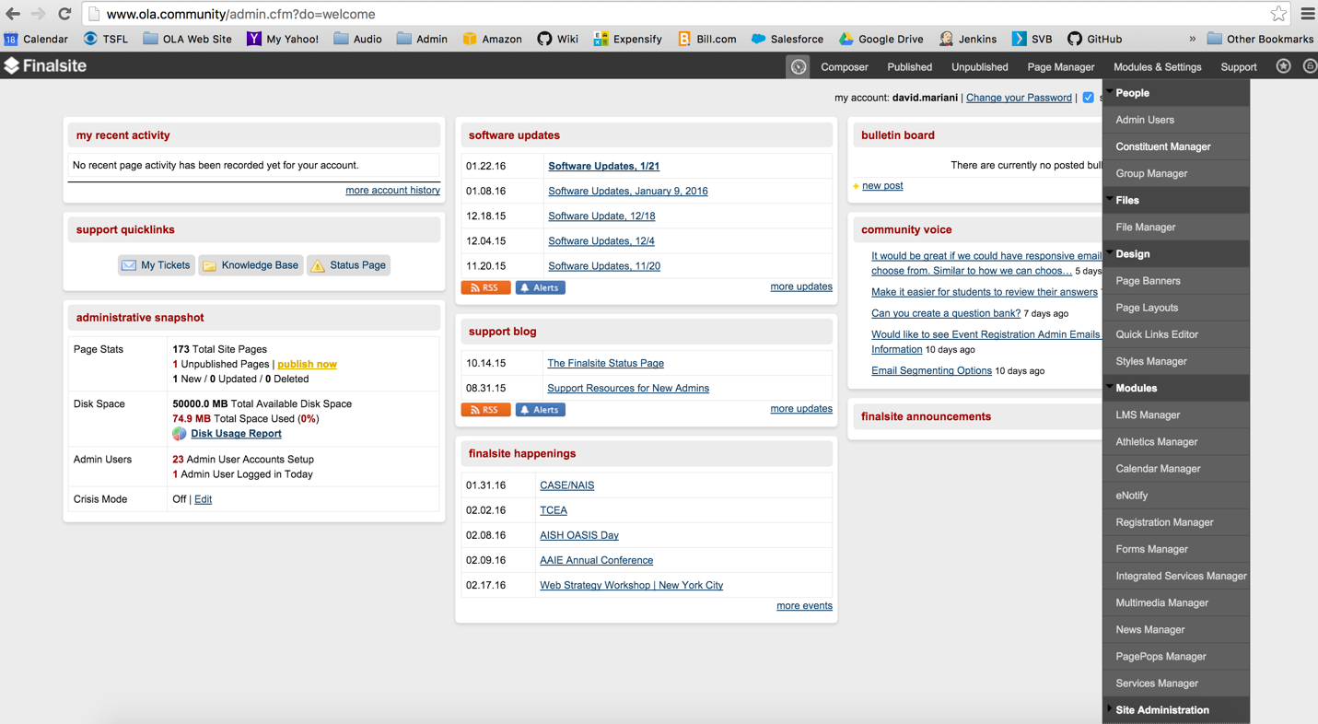

## Step 3: choose **settings** from constituents manager screen

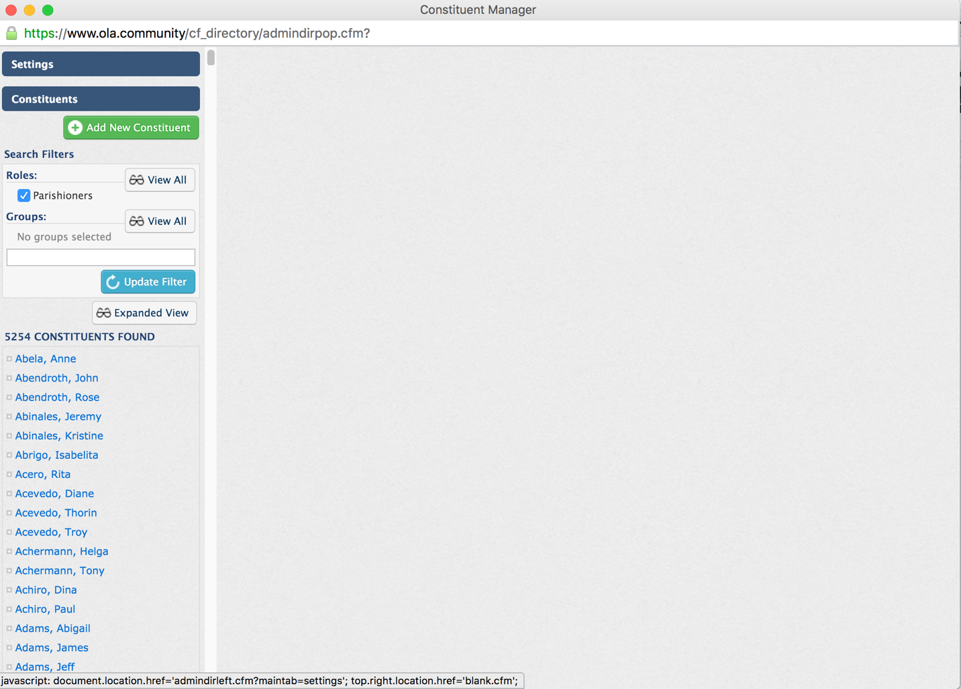

## Step 4: click on **export data**

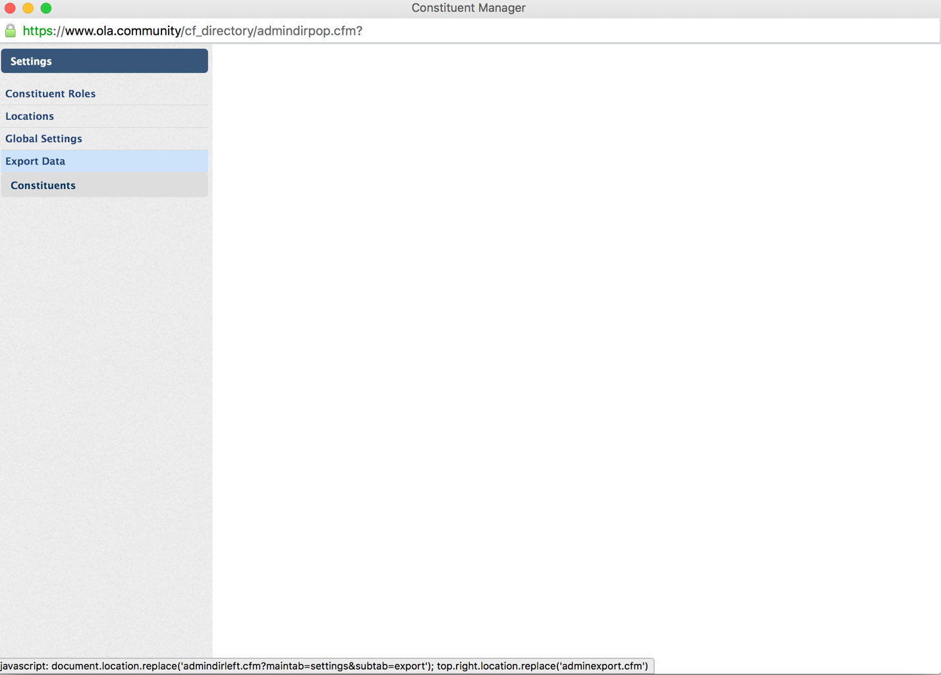

## Step 5: On the **export** drop down, select **parishioners**

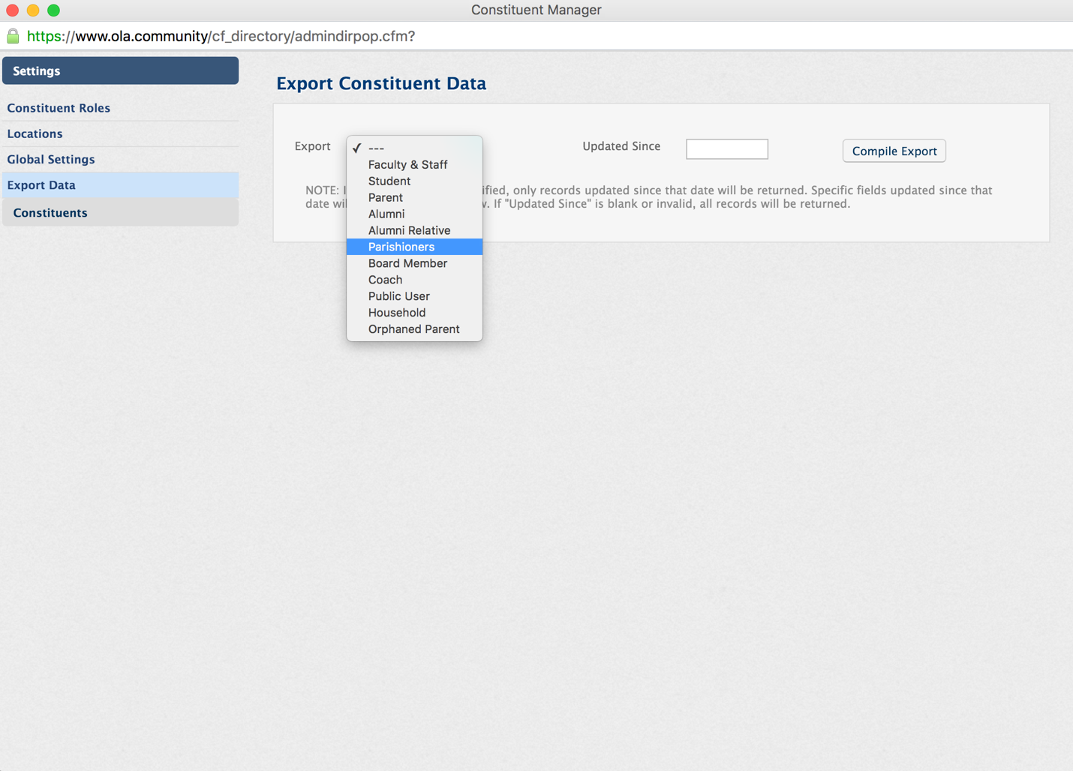

## step 6: enter the **updated since** box and click on the **compile export** button

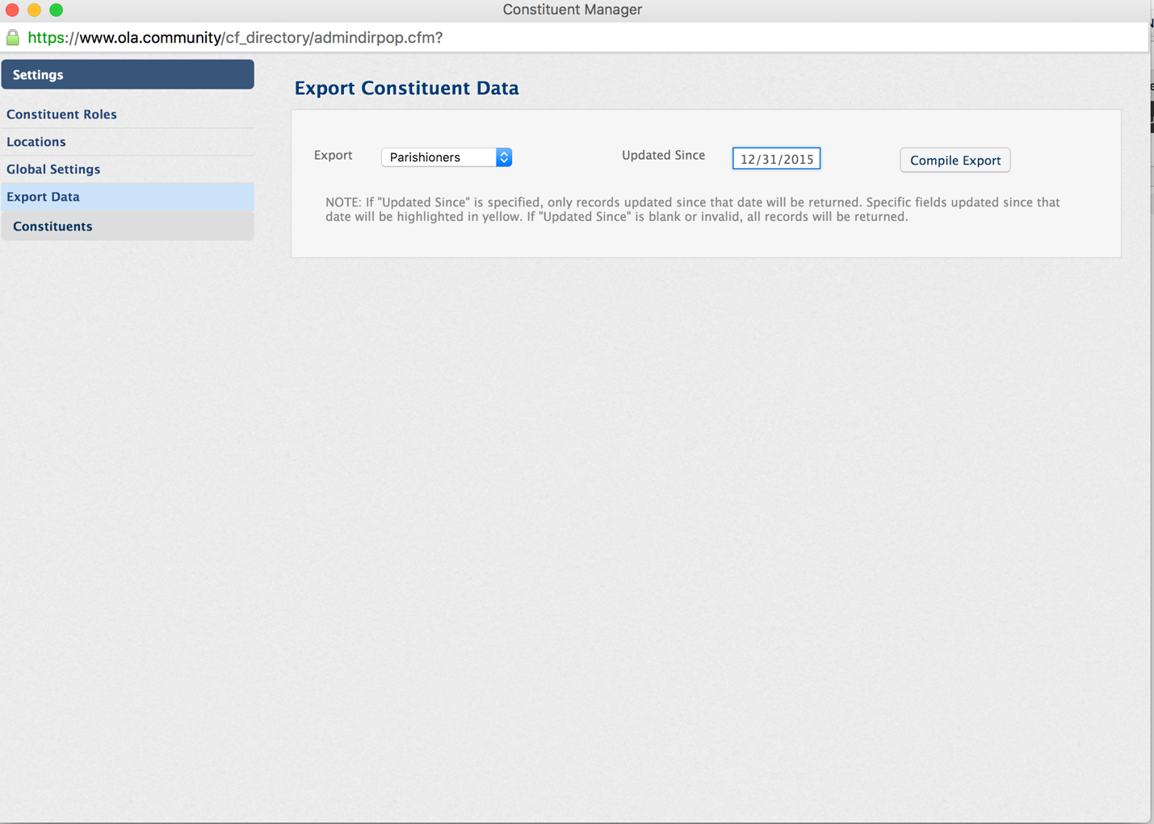

## step 7: click on the **export to excel** button

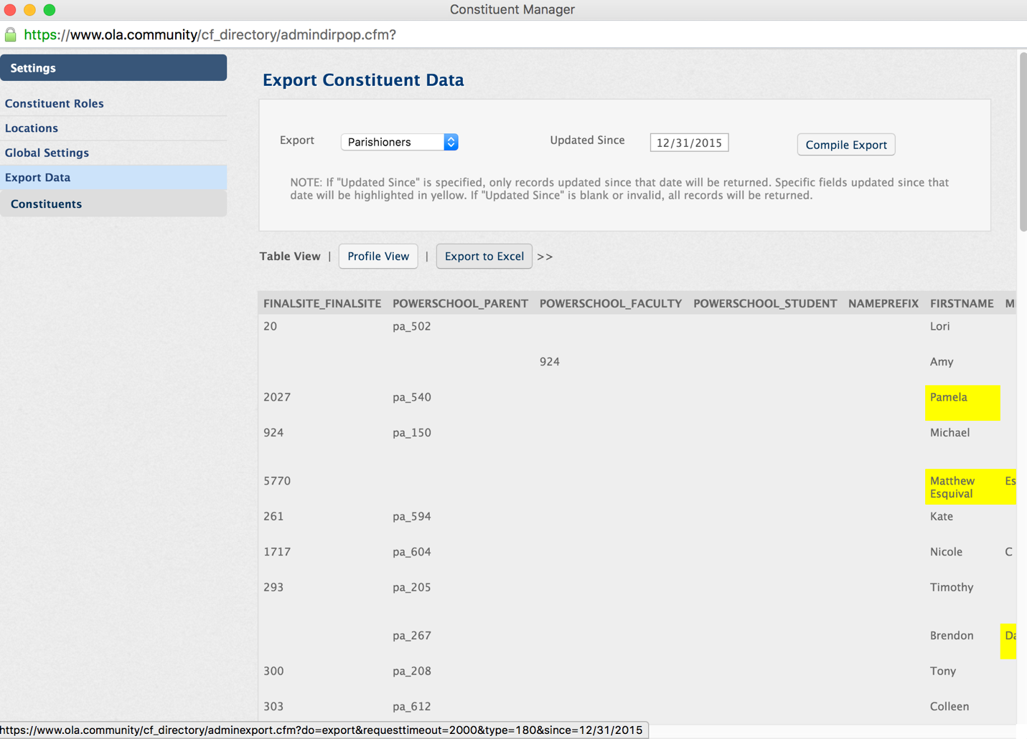

Note: This will automatically create an XLS file in your **Downloads** directory on your computer. This is the file that you will use to import the new/changed data into Servant Keeper.

# Correct Data for Import into PDS Church Office

Launch Excel and load the file created from Step 7.

## Step 1: Remove all fs_ prefixes from the finalsite field

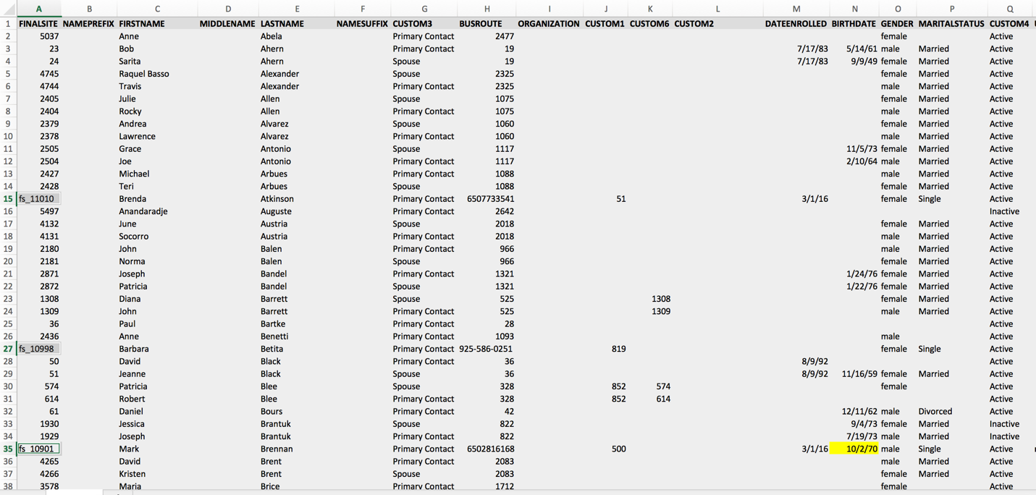

1. Remove the **FS_** prefixes from the column labeled FINALSITE. This is the individualID and the FS_ will cause the record to fail on import into PDS Church Office.

## step 2: Change “primary contact” to “head of household” for CUSTOM3 FIELD



1. PDS Church Office does not understand the term “Primary Contact” as an indicator for “Head of Household”. Replace all entries of “Primary Contact” with the string “Head of Household” in the CUSTOM3 (Family Relationship) field.

## step 3: Change active/inactive to true/false in CUSTOM4 field



1. PDS Church Office does not understand the term “Active” or “Inactive” as an indicator for whether the individual is current active in the parish. Replace the values of “Active” with “True” and “Inactive” with “False” in the CUSTOM4 (Inactive flag) field.

## step 4: Split the file into families.csv and members.csv

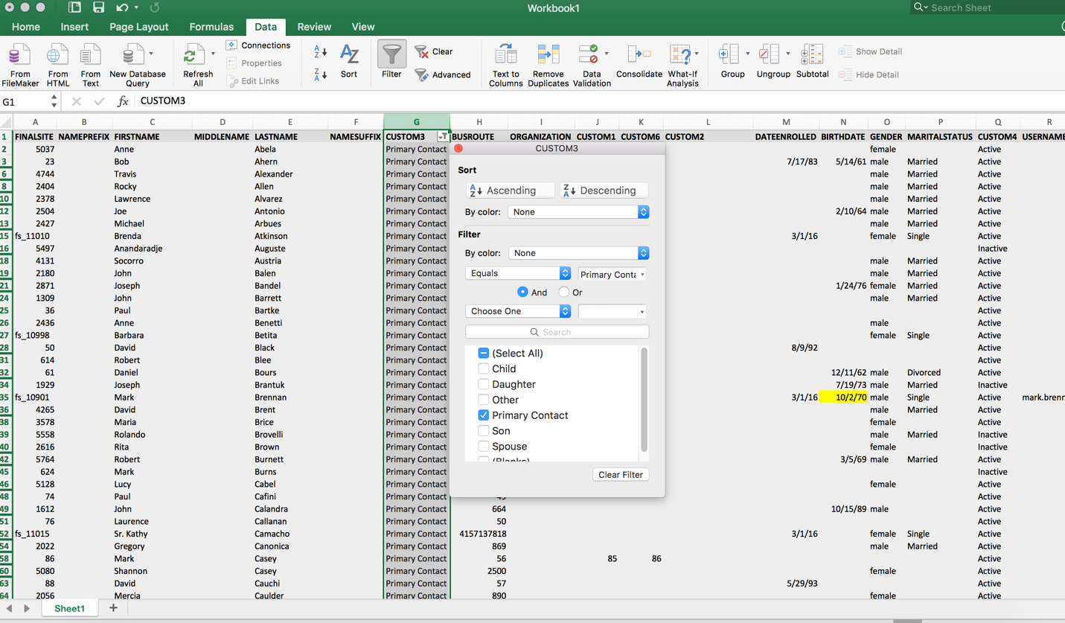

1. PDS Church Office needs a separate import file for the family record versus the individual records. In order to do this, create a filter in Excel on the column CUSTOM3 to filter on only the “Head of Household” records and copy these records to a new Excel file and save it to a file named “**families.csv**”. Make sure to choose the file type a CSV when saving the Excel workbook.
2. Go back to the original file and select all records **except** the “Head of Household” and copy these records to a new Excel file and save it to a file named “**members.csv**”. Make sure to choose the file type a CSV when saving the Excel workbook.
3. You can now import these files, families.csv first, into PDF Church Office.